KENDRIYA VIDYALAYA SANGATHAN , MUMBAI REGION
Academic Session 2025-26 Half Yearly Examination
Subject :Physical Education and Well -being M.M =60
CLASS : VIII SAMPLE PAPER TIME :2 Hours 30 Minutes

General Instructions
- The Paper contains 28 Questions .All the questions are compulsory
- The Paper is divided into 5 parts A,B,C,Dand E
- Section A (Q1 to 16 ):Multiple Choice Question (1 Marks Each ).
- Section B (Q17 to 21 ):Identify the Picture (2 Marks Each ).
- Section C (Q22 to 24 ):Short Answer type question (3 Marks Each ).
- Section D (Q25 to 26):Long Answer Type Question (5Marks Each ).
- Section E (Q27to 29):Competency based Question (5Marks Each ).

Section A (Multiple Choice Question and True/False ) (1x16=16)
Q.NO | QUESTIONS | MARKS
1 | Which of the following is a warm-up activity?  a) Long Jump b) Breathing in Action c) Crawl to the Front d) Kick Volleyball | 1
2 | Which skill is mainly tested in the Crouch or Sitting Start?  a) Flexibility b) Speed c) Endurance d) Strength | 1
3 | Breathing in Action helps in:  a) Body posture b) Mental well-being c) Respiratory health d) All of the above | 1
4 | If a player uses “Flex and React Challenge” regularly, he/she will improve:  a) Reaction time b) Memory c) Jumping ability d) Flexibility | 1
5 | If a team loses in “Kick Volleyball” because players did not pass well, which aspect  should they improve?  a) Strength b) Coordination c) Endurance d) Flexibility | 1
6 | Which activity best prepares athletes for quick starts in athletics races?  a) Crawl to the Front b) Crouch Start c) Move like a Machine d) Baraf Pani | 1
7 | Which of the following situations shows correct application of Cool-Down?  a) Stopping a) suddenly after sprinting b) Jogging slowly after long run c) Doing push-ups after relay  d) Sitting immediately after game | 1
8 | In a Reaction Challenge, two players face each other. The winner is the one who  a) Runs faster b) Reacts quickly to signals c) Shouts loudly d) Shows more strength | 1
9 | The activity "Char Tali" mainly improves  - Flexibility b) Coordination c) Endurance d) Alertness | 1
10 | Warm-up and Cool-down are necessary to prevent injury. (True or False ) | 1
11 | Baraf Pani” is a type of breathing exercise. (True / False ) | 1
12 | If a player fails in Reaction Game, it means his/her reflexes are weak. (True / False ) | 1
13 | Modified Triathlon Activity helps in developing overall physical fitness. (True /False ) | 1
14 | In Crab Crawl Ball Relay, endurance is tested more than balance. (True /False | 1
15 | Swasthya Daud improves only mental health and not physical fitness. (True /False ) | 1
16 | Name of Physical education and well being book for class 8 is Khel Yatra (True /False ) | 1

Section B (Q16 to 20 :Identify the Picture and write the name (2X5=10)
17 | 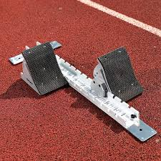 | 2
18 | 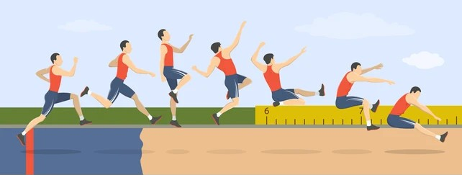 | 2
19 | 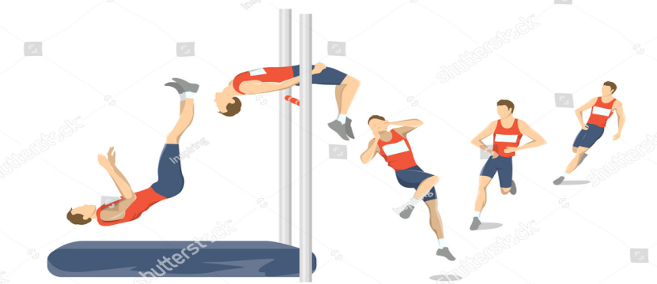 | 2
20 | 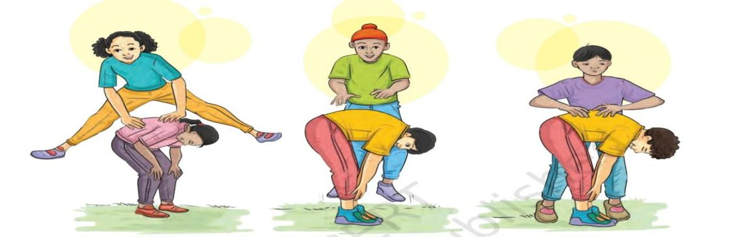 | 2
21 | 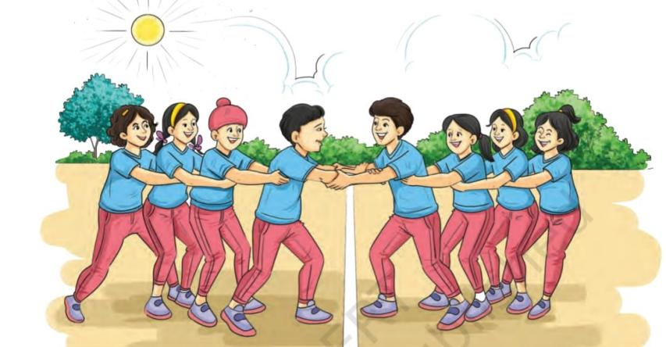 | 2

Section C (Q22to 24) Short Answer type question (3x3=9)
22 | Write types of Couch Start in Athletics ? | 3
23 | While Playing in Team What we learn ? | 3
24 | Pen down any 3 warm-up Exercises? | 3

Section D (Q25 to 26) Long Answer Type Question (5x2=10 )
25 | Describe the technique of Long jump with its Phases ? | 5
26 | Imagine you are the captain of your team in Conduction Relay. How will you motivate and organize your team to ensure victory? | 5

Section E (Q27to 29) Competency based Question (5x3=15 )
27 | During Kick Volleyball, your team is losing because players cannot coordinate passes. Suggest 3–4 strategies to improve coordination and teamwork. ? | 5
28 | “ Breathing in Action” is not only an exercise but also a life skill.Explain with examples how proper breathing  can improve performance in games and daily life? | 5
29 | Suppose you are asked to conduct a Cool-Down session after a long running event. Write the steps you will  follow and explain their importance? | 5

The End

